:

Optimise the discharge of poorly flowing bulk material that tends to form bridges:

- The volume and pressure of the air are individually adjusted to the behaviour of the product.
- With regulated air pressure, pulsated air improves the flow characteristics.
- The combination of vibration and aeration ensures trouble-free discharge!
- PLEASE NOTE: VibraPads have been designed as a discharge aid for products that tend to bridge.
They do not serve the purpose of speeding up the mass flow or making the discharge faster.

These installation / maintenance and operating instructions are concerned with general information.
The use as well as the conditions of use of the SGH VibraPads differ depending on the product,
silo/hopper shape and operating mode etc. Detailed information is described during the course
of the project or in the quotation.

Area of Use and Function

With SGH VibraPads, the discharge of poorly flowing or bridge-forming prone bulk goods from silos, containers and hoppers is effectively supported. They function in that on the one hand through
the external supply of metered compressed air the product is loosened from the container wall
and on the other that the pads are set to vibrate. The vibrations are transmitted to the bulk material
that is also then in turn made to vibrate.

In this way, the so-called “bridging”, that is spoken of when at the discharge opening a type
of stable arch is formed so that the flow of the bulk material stops, is prevented.
Thanks to the vibrations and the aeration, the product can flow out.

Required air pressure: approx. 0.5 – 2.5 bar
Without prior consultation with the manufacturer,
the air pressure must not exceed 2.5 bar!

Interval function: Activation approx. 2 sec / pause time approx. 15-20 sec

The details can vary depending on the product, process and container. Please contact us when necessary.

For product discharge, the SGH VibraPads should be operated exclusively intermittently and
with metered air. Thus, they serve only for the discharge of stalled / poorly flowing bulk material
out of a vessel. Often, a single pulse of metered air is enough, and the bulk material can flow out.
They are not intended for the discharge of a specific amount of bulk material in a specific period of time.

Possible Combinations for VibraPad 100 mm

Pad Material | Colour | FDA | USP Class VI | ATEX | Maximum Temperature¹⁾ |  | Aeration Stud in VA
Silicone | white | x | - | x | 180°C |  | 1.4305 | AISI 303 | V2A
Silicone | white | x | x | x | 180°C
Silicone | blue | x | - | x | 180°C |  | 1.4301 | AISI 304 | V2A
Silicone DETECT²⁾ | blue | x | - | x | 180°C |  | 1.4541 | AISI 321 | V2A
Silicone HOT | red | - | - | x | 300°C
EPDM | cream | x | - | x | 125°C |  | 1.4404 | AISI 316L | V4A
EPDM | grey | - | - | x | 125°C
EPDM | black | - | - | x | 125°C |  | 1.4539 | AISI 904L | V5A
Neoprene | black | - | - | x | 125°C
Viton | black | - | - | x | 200°C
Rhodorsil | grey | - | - | x | 300°C
FKM | white | x | x | x
FFKM | white | x | x | x

¹⁾ short-term temperature peaks ²⁾ metal detectable pad ³⁾ non-product contacting

Possible Combinations for VibraPad 100 mm SAN

Pad Material | Colour | FDA | ATEX | Maximum Temperature¹⁾ |  | Aeration Stud in VA
Silicone | white | x | x | 180°C |  | 1.4305 | AISI 303 | V2A
Silicone | blue | x | x | 180°C

Possible Combinations for VibraPad mini 50 mm

Pad Material | Colour | FDA | USP Class VI | ATEX | Maximum Temperature¹⁾ |  | Aeration Stud in VA
Silicone | white | x |  | x | 180°C |  | 1.4404 | AISI 316L | V4A
Silicone | white | x | x | x | 180°C
Silicone | blue | x |  | x | 180°C
Silicone DETECT²⁾ | blue | x |  | x | 180°C
Silicone HOT | red | - |  | x | 300°C
EPDM | cream | x |  | x | 125°C
EPDM | grey | - |  | x | 125°C
EPDM | black | - |  | x | 125°C
Neoprene | black | - |  | x | 125°C
Viton | black | - |  | x | 200°C
Rhodorsil | grey | - |  | x | 300°C
FKM | white | x | x | x
FFKM | white | x | x | x

¹⁾ short-term temperature peaks ²⁾ metal detectable pad ³⁾ non-product contacting

Installation

One or more holes are drilled in the wall of the silo cone. The position of the holes is determined
by the problem areas in the cone and / or by the manufacturer’s installation recommendations.
The diameters of the holes are dependent on the particular product.

The VibraPads are mounted from the inside or from the outside with the SGH external mounting aid.
The flexible pad adjusts itself to the vessel shape. The outer edge of the pad prevents the backflow
of the product. Please note that the nut(s) need only be hand tightened. With external mounting,
the centring disc must always be fitted vertically. Depending on the circumference of the cone,
the thrust washer must be adapted to this circumference.

The air supply takes place via the internal thread of the bolt (alternatively, the external thread
is also possible). The cross section of the air supply is dependent on the number of VibraPads.
With numbers of VibraPads up to 10, a ¼” air line is sufficient. For higher numbers,
we recommend a ½” air line.

Required air pressure: approx. 0.5 – 2.5 bar
Without prior consultation with the manufacturer,
the air pressure must not exceed 2.5 bar!

Interval function: Activation approx. 2 sec / pause time approx. 15-20 sec

The details can vary depending on the product, process and container. Please contact us when necessary.

Mounting from inside | Mounting hole size | VibraPad type | External thread | Internal thread
 | Ø 20 mm | VibraPad 100 mm | UNC ¾” | G ¼”
 | Ø 22 mm | VibraPad SAN 100 mm | G ½” | G ¼”
 | Ø 14 mm | VibraPad mini 50 mm | G ¼” | G 1/8”

The pad + aeration stud are mounted from inside: The aeration stud is pushed through the drilled opening until the pad lies against the inside of the vessel. Then the silicone sealing ring, thrust washer, flat washer and nut(s) are mounted from the outside. It is sufficient to tighten the nuts only hand tight.

When mounting into a round silo cone, the thrust washer must be matched to the radius

Please ensure that the vessel inner wall is free of chips or product residues. Mount the VibraPads only
on a level surface (that is, not on weld seams or bulges).

The elastomer pads / pads are wear parts. Please carry out regular visual inspections

Mounting from outside | Mounting hole size | VibraPad type | External thread | Internal thread
 | Ø 50 mm | VibraPad 100 mm | UNC ¾” | G ¼”
 | Ø 60 mm | VibraPad SAN 100 mm | G ½” | G ¼”
 | Ø 29 mm | VibraPad mini 50 mm | G ¼” | G 1/8”

The pad + aeration stud with the mounting rod screwed on are mounted from the outside: The aeration stud
along with the pad is carefully pushed through the drilled opening after which the counter plate is inserted
into the vessel at an angle and counter-tightened with the mounting handle until the pad and counter plate
lie against the inner side of the vessel. It is sufficient to tighten the nuts only hand tight. Please ensure
that the vessel inner wall is free of chips or product residues. Mount the VibraPads only on a level surface
(that is, not on weld seams or bulges).

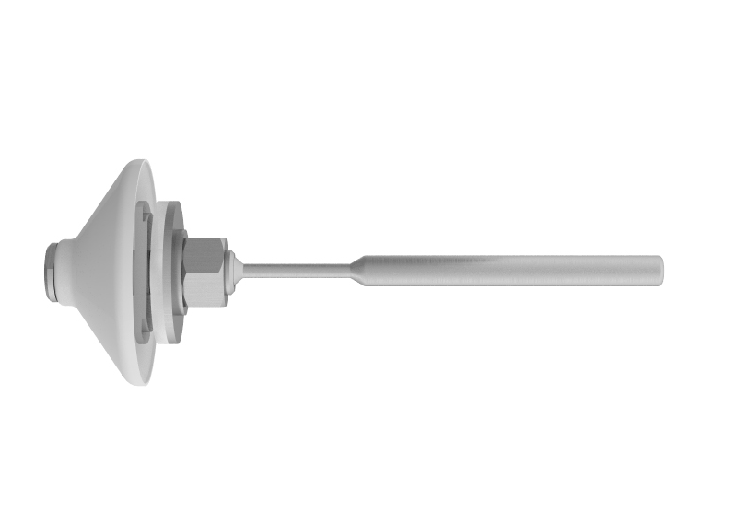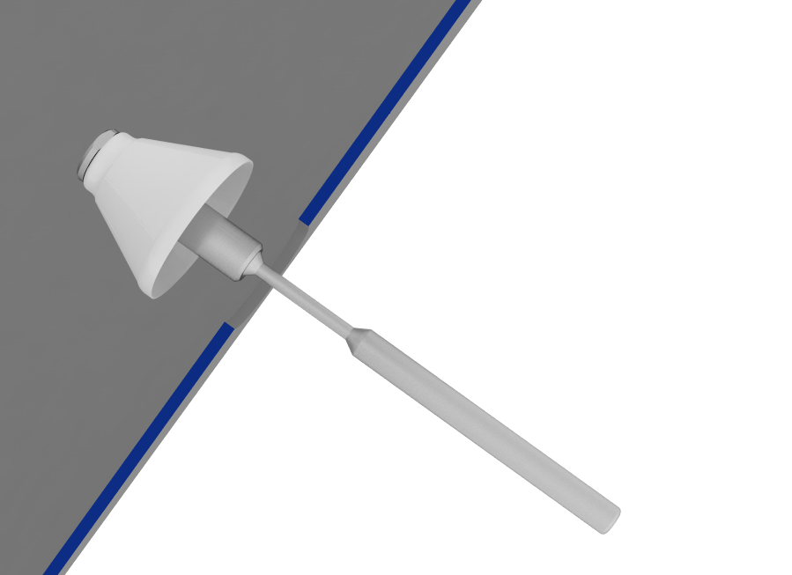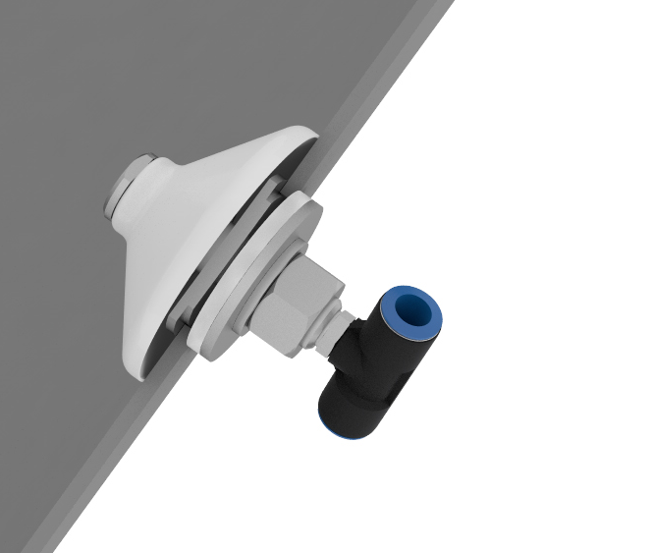

Please make sure that the counter plate is positioned vertically

Then the silicone sealing ring, thrust washer, flat washer and nut(s) are mounted from the outside.
The final step is to remove the mounting rod.

When mounting into a round silo cone, the thrust washer must be matched to the radius

On request, we will gladly supply precisely fitting FESTO push-in fittings and sleeving.
Our pneumatic turnkey controller (FESTO) is likewise optionally available.

The elastomer pads / pads are wear parts. Please carry out regular visual inspections

Recommended Installation

The number of VibraPads and their installation depend on various factors such as the product's flow behaviour and the vessel's size and shape. The arrangement of the VibraPads is essential for their effectiveness – we will gladly advise you on this!

VibraPads are installed in the cone of the hopper/silo. The bulk material, vessel size and diameter
determine how many VibraPads are needed. Depending on the cone size, generally 3-4 VibraPads
are distributed over the perimeter in the first row, starting at about 200 - 450 mm above the outlet.

A second row of x VibraPads is installed 450 - 600 mm above the first row, their position being offset
to row 1.

Depending on the silo size, more pads/rows can be installed. The distance of the VibraPads
from one another varies in direct relationship to the funnel height/diameter of the silo/hopper.

Generally, 2 to 6 VibraPads can be connected in series, with more than 6 pads, we recommend
a separate supply line.

These standard recommendations must always be adapted
to the individual on-site requirements.

Amount of Air Required

We recommend that the VibraPads are operated by pulsing air on and off at a suitably regulated pressure.
The product and the number of VibraPads determine the air pressure and pulse durations.

A higher air pressure and pulse rate produce more vibration thus preventing caking or bridging of products that tend to adhere. Adhering products, therefore, need this higher air pressure and pulse rate.
With dry products that are less prone to bridge formation, a lower air pressure and pulse rate produce improved flow behaviour.

Calculation of Air Consumption

VibraPads are operated in pulses. A guide value for the air consumption in m³/h is calculated by multiplying together the aeration time/minute, air pressure and the number of VibraPads. The ON and OFF durations
(1 cycle) are dependent on the particular application.

Example: Number of VibraPads 4
 |  | m³ / Aeration nozzle
 |  | Pulse time in seconds
bar | m³/min. | 1 sec | 2 sec | 3 sec
3.0 | 1.235 | 0.021 | 0.042 | 0.061
2.5 | 0.967 | 0.016 | 0.032 | 0.048
2.0 | 0.680 | 0.011 | 0.022 | 0.034
1.5 | 0.615 | 0.010 | 0.020 | 0.031
1.0 | 0.459 | 0.008 | 0.015 | 0.023
0.5 | 0.255 | 0.005 | 0.008 | 0.013

Air pressure 2 bar
ON time 2 sec
OFF time 10 sec
1 cycle 12 sec

60/12 = 5 cycles/min

5 x 0.022 (air consumption at 2 bar) x 4 VibraPads
= 0.44 m³/min

VibraPad ∅ 100 mm VibraPad mini ∅ 50 mm
for internal mounting for internal mounting

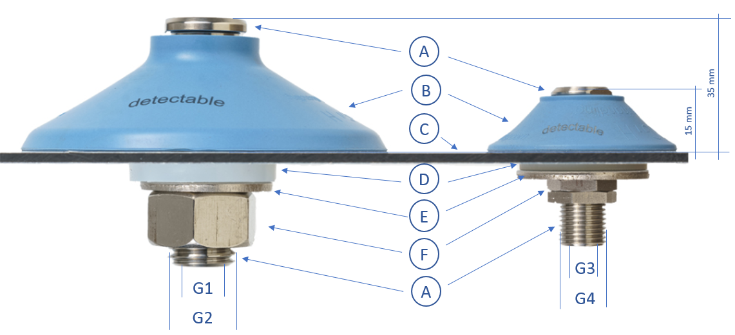

A | Aeration stud
B | Pad Ø100mm / pad mini Ø50mm
C | Silo wall
D | Sealing ring
E | Thrust washer(s)
F | Hexagonal nut(s)
G1 | Connector internal thread: G1/4”
G2 | Connector external thread: UNC ¾” or G1/2”
G3 | Connector internal thread: G1/8”
G4 | Connector external thread: G1/4”
J | O-ring* (not to be seen above)

* only included with VibraPad mini

VibraPad ∅ 100 mm VibraPad mini ∅ 50 mm
for external mounting for external mounting
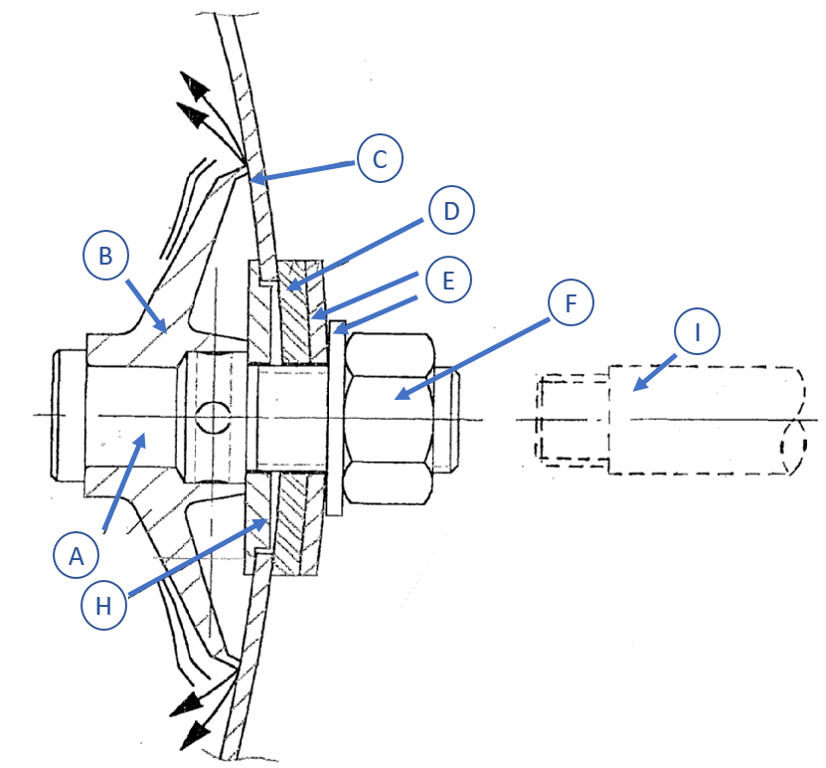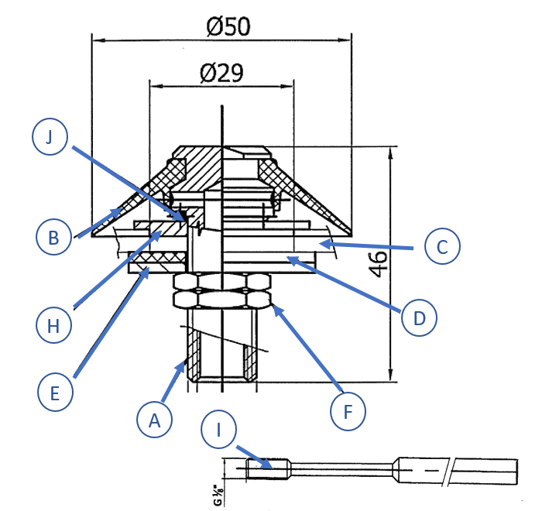

A | Aeration stud
B | Pad Ø100mm / pad mini Ø50mm
C | Silo wall
D | Sealing ring
E | Thrust washer(s)
F | Hexagonal nut(s)
G1 | Connector internal thread: G1/4”
G2 | Connector external thread: UNC ¾” or G1/2”
G3 | Connector internal thread: G1/8”
G4 | Connector external thread: G1/4”
H | Centring disc / counter plate*
I | Mounting handle*
J | O-ring**

* only necessary for external mounting
** only included with VibraPad mini

